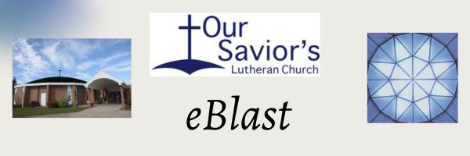
September 9, 2026

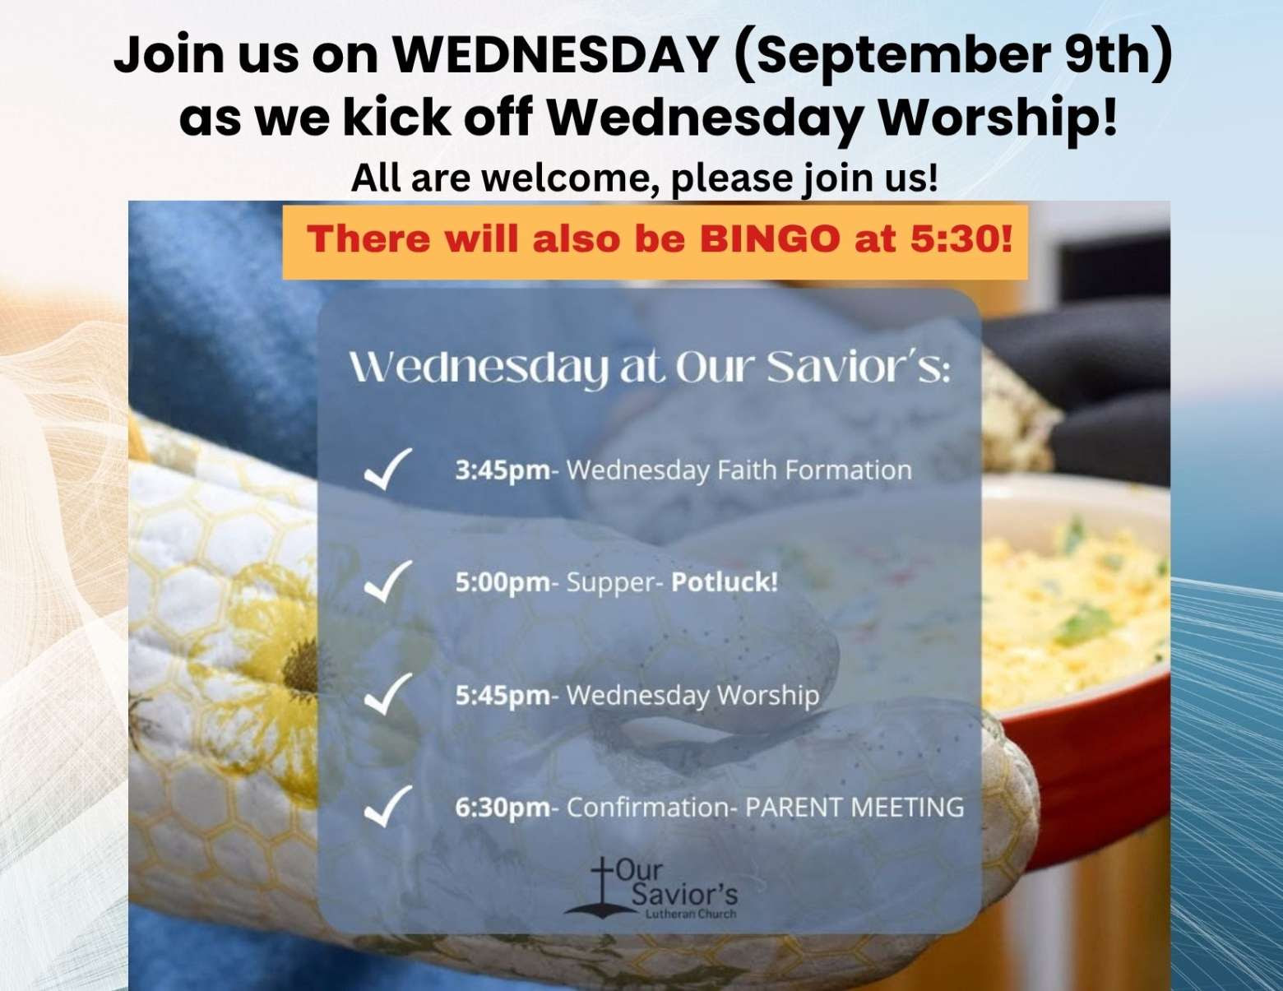
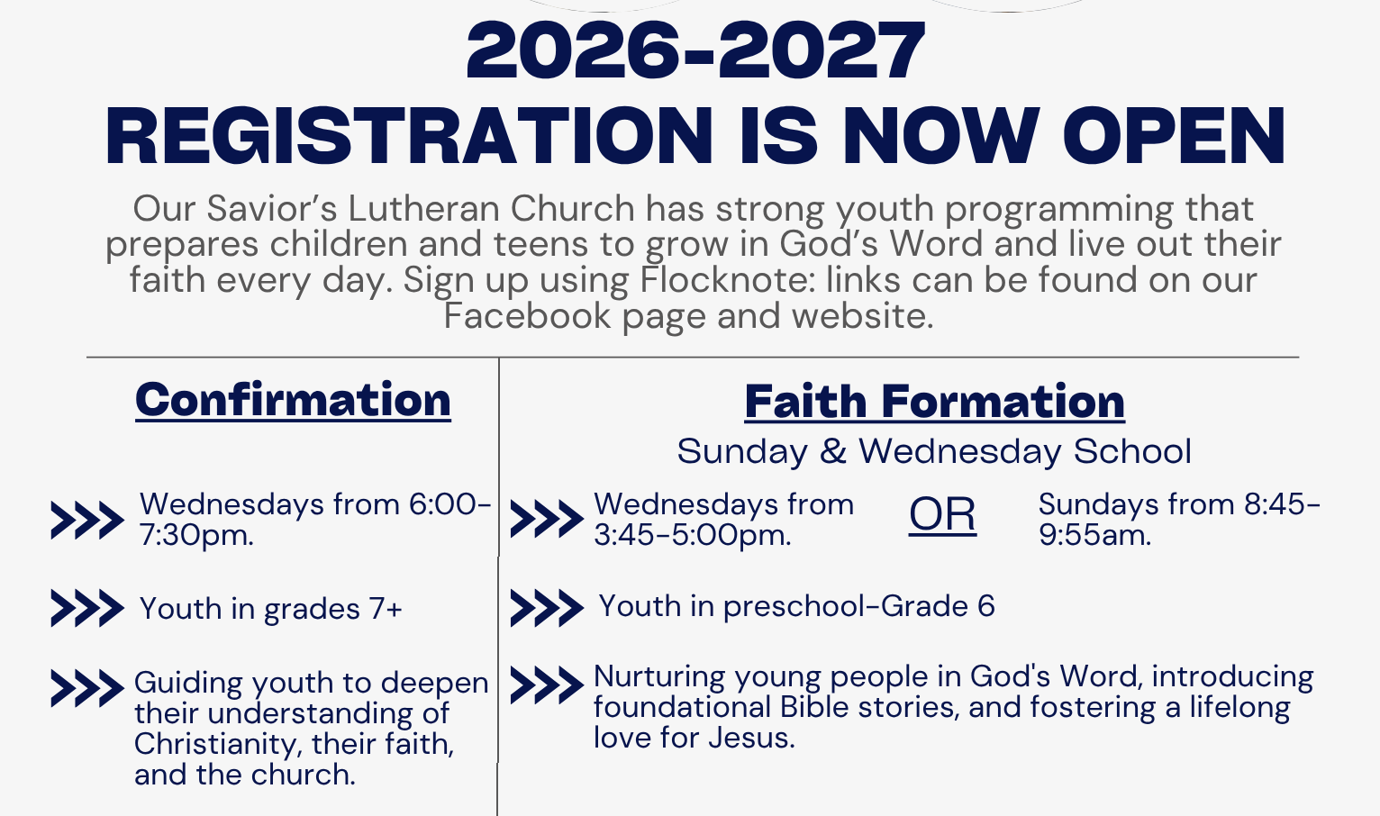
→ Confirmation Link: https://oursaviorslutherandl.flocknote.com/signup/269488
→ Faith Formation (both Wednesday and Sunday): https://oursaviorslutherandl.flocknote.com/signup/269490
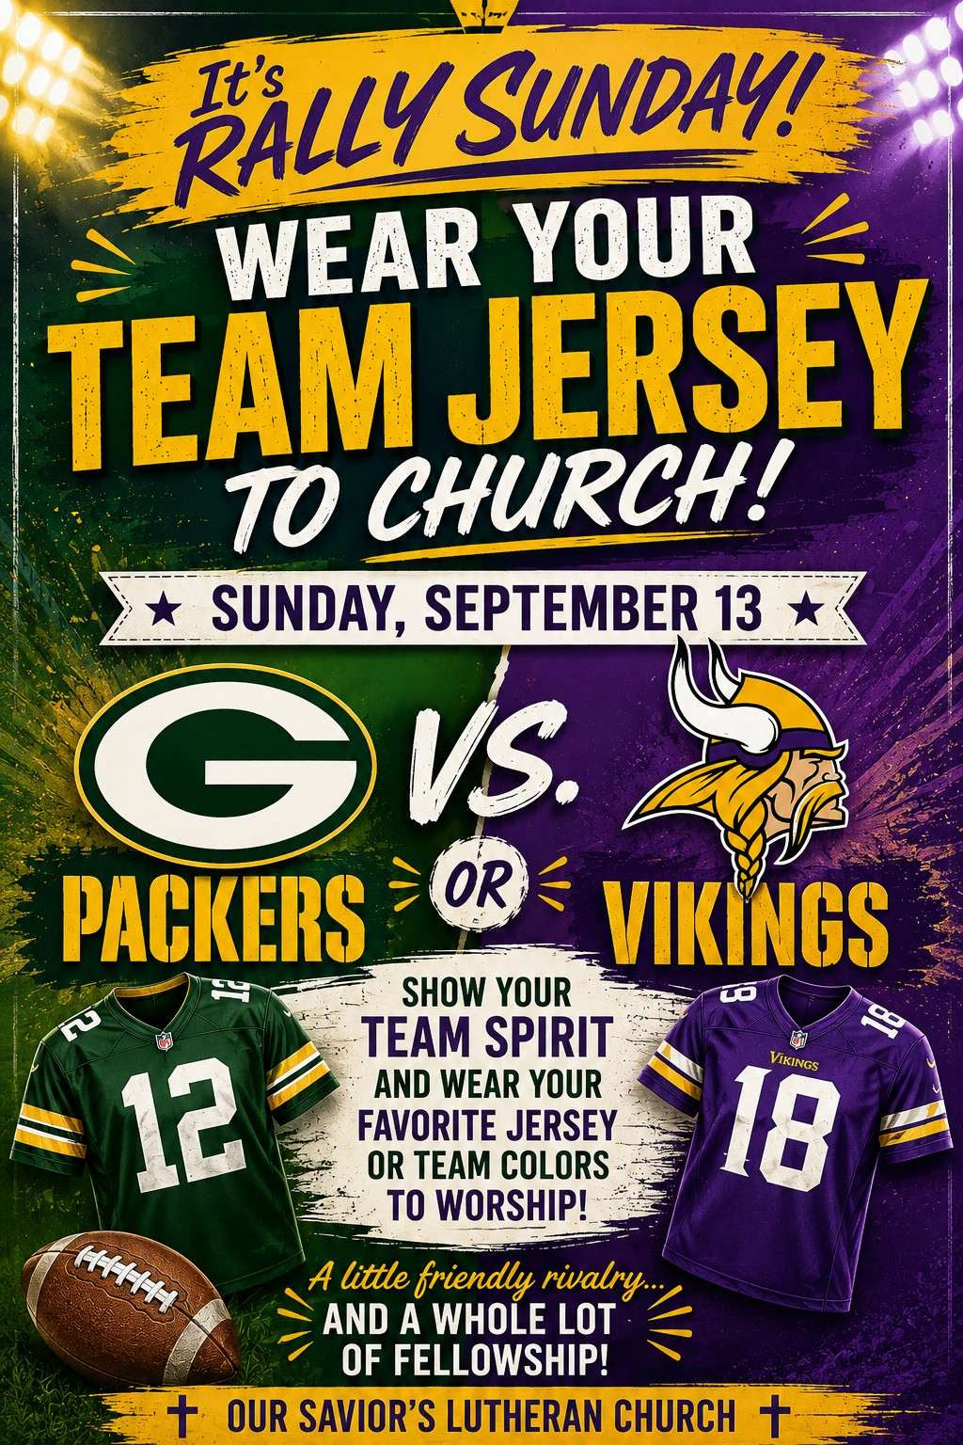

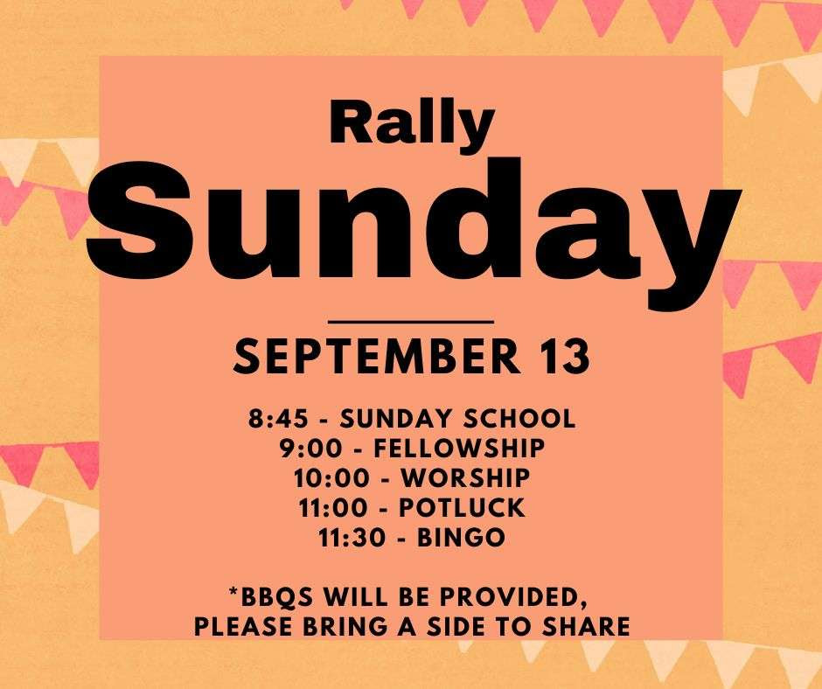

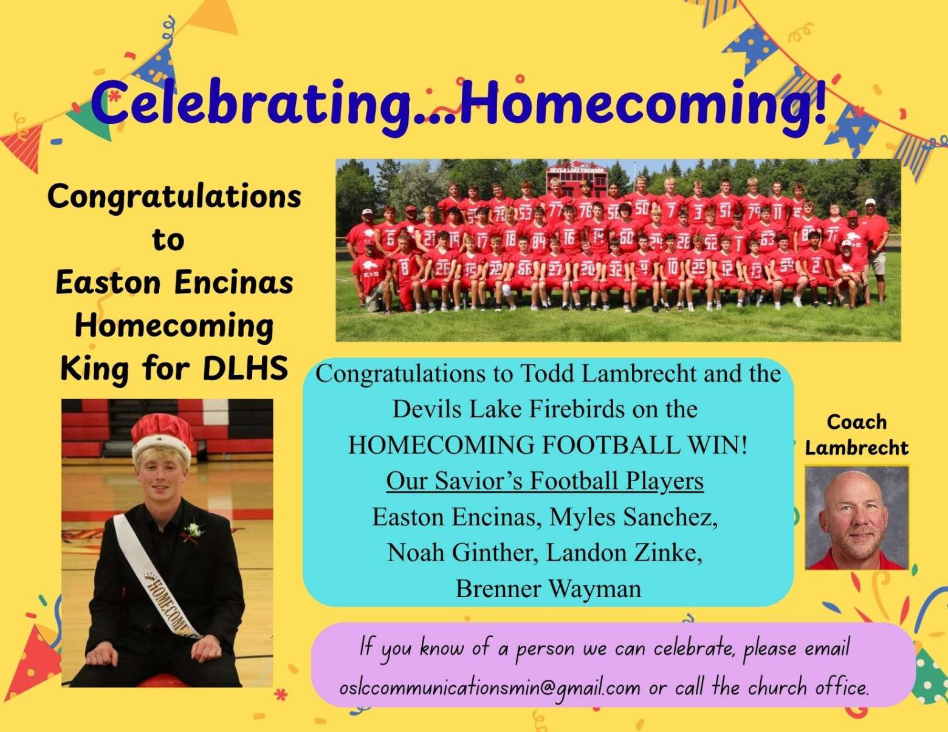

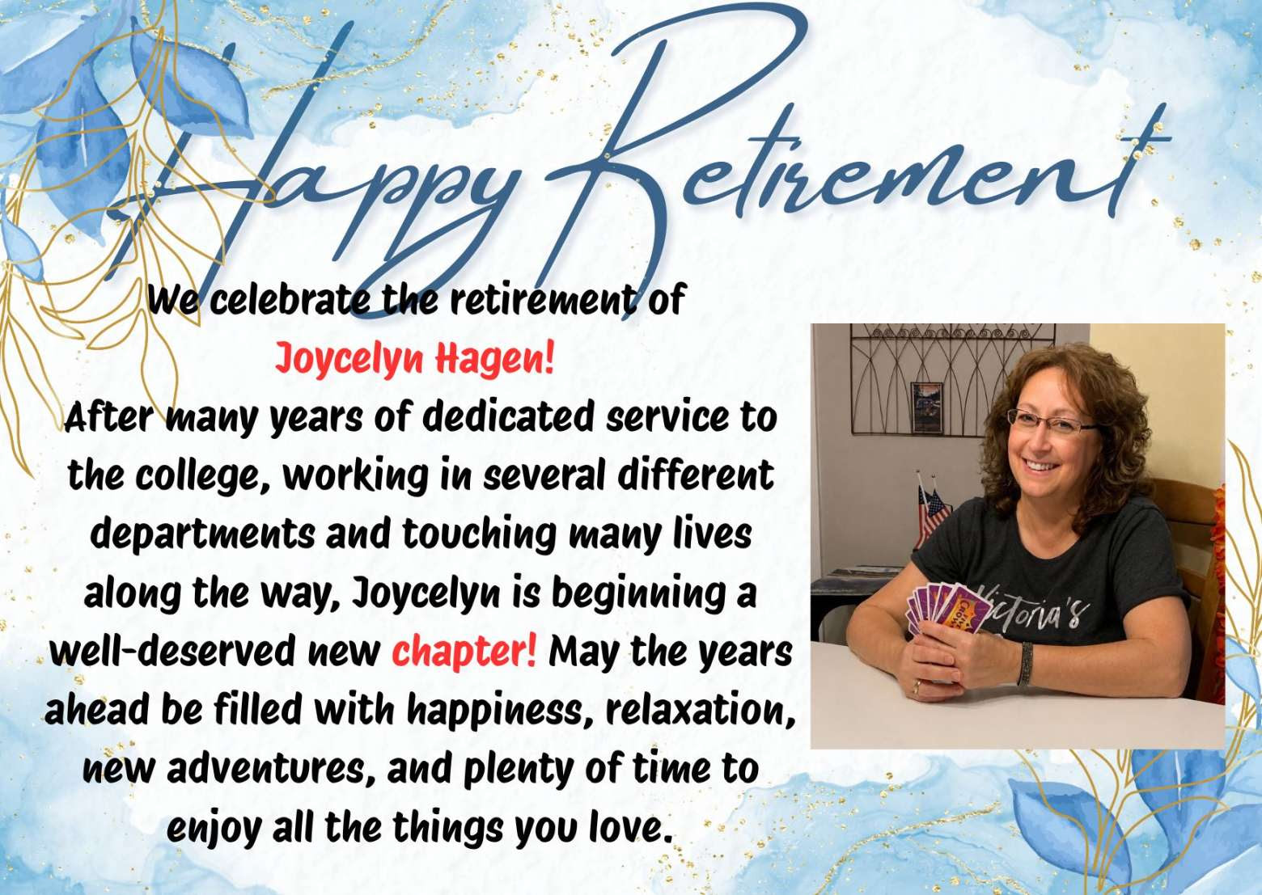
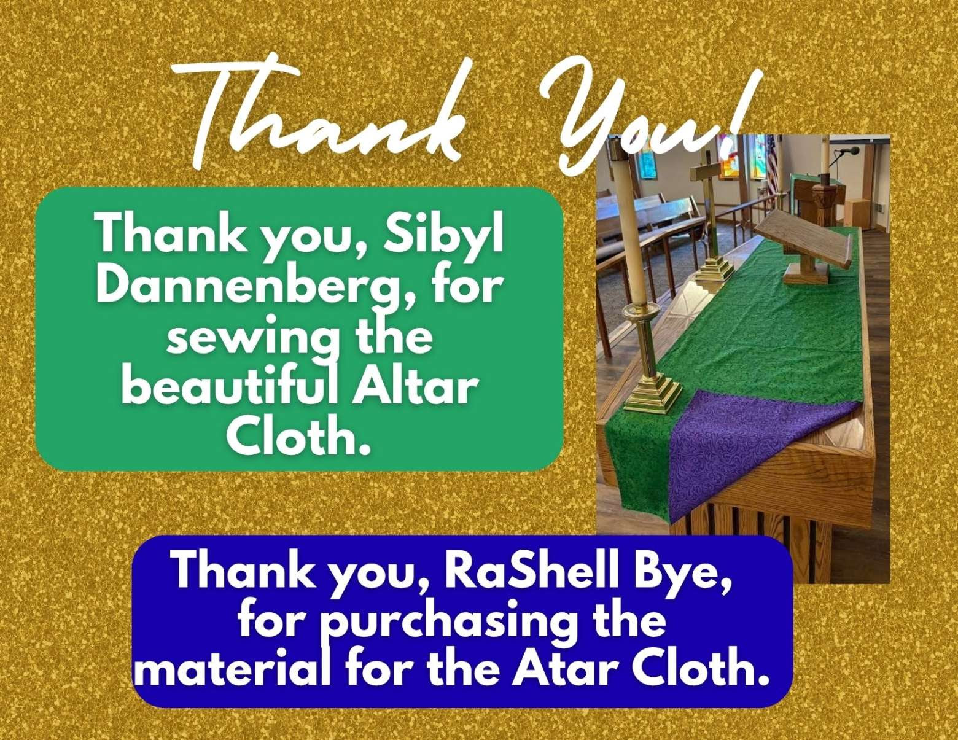

You can begin thinking about gently used Christmas decorations and items to donate for the Christmas Rummage Sale! Plans are beginning for the BIG Lefse Sale!
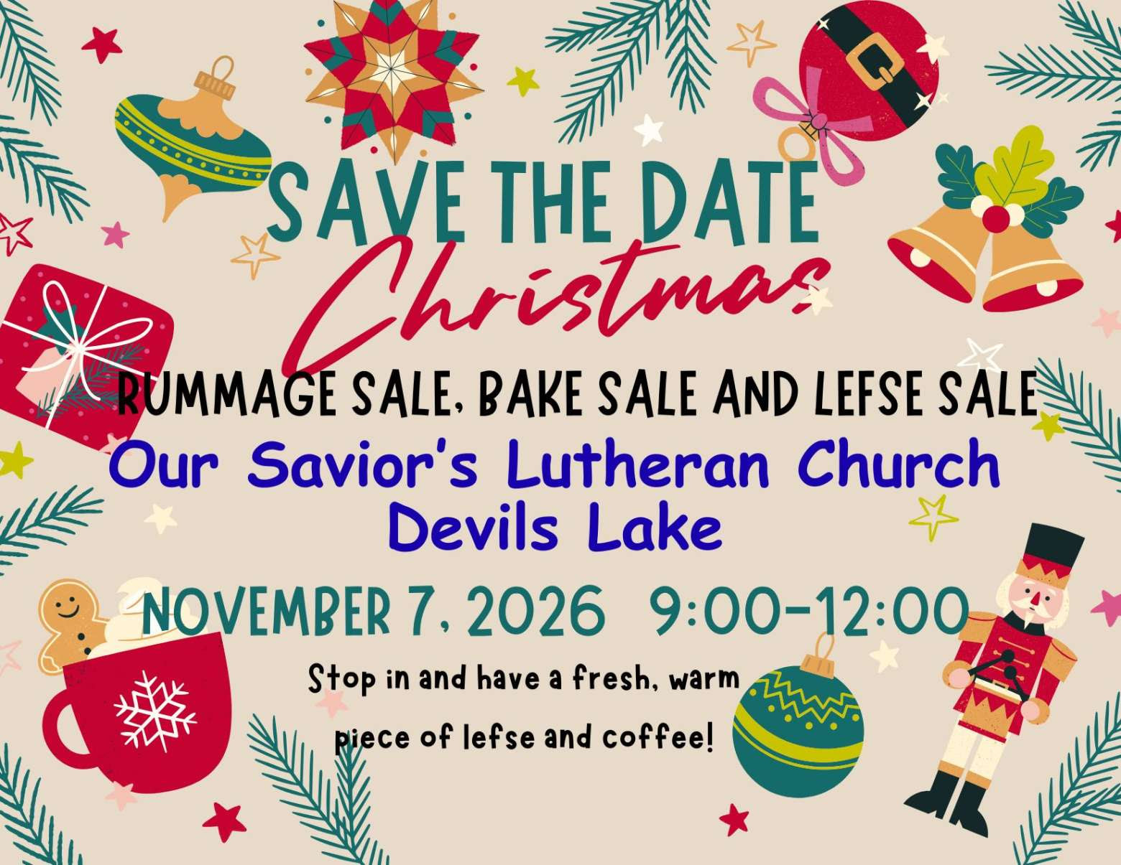

Upcoming Events at Our Savior's Lutheran Church
Wednesday, September 9
RALLY WEDNESDAY!
3:45 Faith Formation First Day
5:00 p.m. Potluck Supper & BINGO
6:30 p.m. Confirmation Meeting with Students and Parents
Sunday, September 13
RALLY SUNDAY!
8:45 Faith Formation First Day
9:00 a.m. Coffee Fellowship & Birthday Cupcakes
10:00 a.m. Service of Holy Communion led by Visiting Pastor Kate Bohmer
11:00 a.m. Potluck Lunch & BINGO
Wednesday, September 16
RALLY WEDNESDAY!
3:45 Faith Formation
5:00 p.m. Supper
5:45 p.m. Worship
6:30 p.m. Confirmation Meeting with Students and Parents
Sunday, September 20
8:45 Faith Formation
9:00 a.m. Coffee Fellowship
10:00 a.m. Service of the Word led by Visiting Lay Minister Alana Erickson
Monday, September 21
Council Meeting 5:15 p.m.

Thank you for your continued generosity to
our church family.
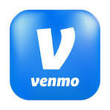
We are pleased to offer Venmo as a simple and convenient way to give using the link below:

https://www.venmo.com/u/OurSaviorsDL

You are receiving this email because you are a member or a friend of Our Savior's Lutheran Church.
Our Savior's Lutheran Church
612 14th Ave NE
Devils Lake, North Dakota 58301
701-662-5112
office@oursaviorsdevilslake.org

